**Brooklyn torah gazette**

**For parshas va’eschanan 5783**

Volume 7, Issue 45 (Whole Number 352) 11 Menachem Av 5783/ July 29, 2023

**Printed L’illuy nishmas Nechama bas R’ Noach, a”h**

For a free subscription, please forward your request to [***keren18@juno.com***](mailto:keren18@juno.com)

**How to Improve in the**

**Mitzvah of Ahavas Yisroel**

**By Daniel Keren**

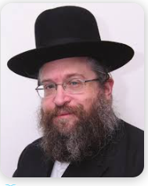

**Rabbi Fischel Schachter**

One of the featured speakers at the recent Flatbush 2023 Independence Day Hakhel Event was Rabbi Fischel Schachter and he addressed the topic of how to utilize the Three Weeks to grow in one’s Ahavas Yisroel, the mitzvah of loving a fellow Jew.

Speaking about the mitzvah of eynayim (controlling one’s eyesight from looking at immoral and amoral sights), Rabbi Schachter declared that if you fix what you look at, you will automatically control your heart and one must constantly focus one’s efforts to control one’s heart or desires.

In the end of Parshas Balak, Pinchas first looked around, hoping that everything would all right. Only after he saw the problem [of Zimri consorting with the Midianite princess in public view] did he grasp the spear. Other so-called kanaim (zealots) really want the excuse to be able to run and grab that spear.

Rabbi Schachter challenged the Hakhel audience with the question of what is the difference between a housewife and a cat? The simple answer is that the housewife hopes not to find a mouse, whereas the cat truly seeks out the hapless rodent.

**Hashem’s Way of Giving Us a Second Chance**

Every summer before Rosh Hashanah, Rabbi Schachter noted that there seem to be in the life of every Jew a review of some of the major spiritual challenges that occurred in his or her life during the past year. Instead of being upset by these repeats, one should recognize that this is Hashem’s way of giving each and every one of us a second chance to correct our spiritual failures of the previous months and do teshuvah before the coming of Rosh Hashana 5784. Many of the disappointments in our life are just readjustments that are prepared by Hashem to help a person refine him or herself.

With the challenge of eynayim, controlling one’s eyesight from glancing at forbidden matters, Rabbi Schachter said, that every time one successfully overcomes such immoral temptations, you gain a wonderful spiritual reward [even if you fail this same mitzvah on other occasions]. The more a person works on his or her own kedushah (holiness,) the more one converts his or her greatest spiritual challenges and failures into wonderous zechusim (merits).

Rabbi Schachter spoke on the related question of just how hard should one work on developing Ahavas Yisroel with a particularly difficult spouse. He told of a man who was basically a gentle person, but who had married a woman whom after the chupah, he discovered to be a truly a very difficult and critically demanding wife who made his life very challenging, to say the least.

**The Husband’s Desire to End His Misery**

It got to the point where he even spoke to Rabbi Schachter about his desire to end his misery by obtaining a get (divorce). The rabbi’s advice was that since this was the wife that G-d gave him, he should still try and work it out by trying to increase his Ahavas Yisroel for his wife and that this could improve the way she treats him.

The man, however was not interested in trying that possible solution and insisted that he had no alternative but to end his marriage. But before he could do so, he unfortunately caught a very deadly strain of COVID and was hospitalized and intubated because he had serious difficulties in breathing. After a few weeks without any significant improvement in his condition, the doctors gave up on the patient and announced their decision to simply pull the plugs and use the intubator on another COVID patient who might have a better chance of survival.

But those doctors didn’t take into account the patient’s wife. She burst through the security barrier intended to keep out close family members and rushed to the room where her husband was being treated. She loudly threatened the doctors that under no condition would she allow them to pull the plugs and kill her “beloved” husband. Afraid to deal with her the doctors changed their mind and sure enough the husband did improve and was able in a few weeks to leave the hospital alive because of his wife’s strong reaction on his behalf.

Rabbi Schachter challenged the husband by asking him where do you think you would be if you had actually divorced you wife and she would not have been there to stand up on your behalf against the doctors and protected you from being killed when the plugs would have been removed from the incubator? And what if your wife wasn’t so difficult and would have been unable to intimidate the doctors from pulling the plugs? And shouldn’t that be an incentive and inspiration for the husband to work extra hard on developing a stronger Ahavas Yisroel towards his wife that as Rabbi Schachter said could also inspire her to in turn to develop a greater Ahavas Yisroel for her husband.

**Thoughts that Count for Our Parsha**

*Take therefore good heed of yourselves* (Deut. 4:15)

According to Torah law, a Jew is required to take care of his body and refrain from things that are harmful. But a person must never place too much emphasis on his own physical welfare, while treating someone else's spirituality as his own domain, i.e., offering unasked-for reprimands and comments about the other person's conduct. In fact, the correct order is the reverse: As regards the self, an individual's primary focus should be spiritual. But when relating to others, the primary concern should be helping with material needs. (Rabbi Yisrael of Salant)

*I beg you, let me go over, and see the good land* (Deut. 3:25)

At first glance, Moses' request that he "see the good land" seems superfluous; if G-d allowed him to cross over the Jordan, wouldn't he automatically "see" the land? Rather, Moses was praying to avoid the same transgression as the Twelve Spies, and see only the "good" in the Land of Israel. (Rabbi Menachem Mendel of Kotzk)

*Reprinted from the Parshat Ve’etchanan 5760/2000 edition of L’Chaim.*

**The Significance of a Jew’s Recitation of Kriyat Shema**

**From the Teachings of the Lubavitcher Rebbe**

**Rabbi Menachem Mendel Schneerson, Zt”l**



This week's Torah portion, Vaetchanan, contains the central proclamation of our faith, "Shema Yisrael - Hear O Israel, the L-rd is our G-d, the L-rd is One. And you shall love...and you shall speak of them...when you lie down and when you rise...and upon your gates."

One of the Torah's positive commandments is to recite the Shema twice each day. The Torah specifies when we must say it: "when you lie down," i.e., at night, and "when you rise," i.e., during the day.

With the declaration of "Shema Yisrael," the Jew testifies that G-d is One, and that nothing else exists except for Him.

The word echad, one, is composed of three letters: alef, chet and dalet.

The numerical equivalent of alef is one. G-d is alone and unique in the universe.

The numerical equivalent of chet is eight. Only G-d is King over all seven firmaments and the earth below.

The numerical equivalent of dalet is four. This expresses the concept that G-d is the sole Sovereign over all four directions: east, west, north and south.

By saying Kriyat Shema, a Jew negates the independent existence of the world. He declares that all of creation - the celestial spheres, the earth below and the four winds - are completely nullified before Him. G-d is the One Who sustains and rules over them; without Him, they would not exist. G-d is One; there is nothing else but Him.

A Jew is obligated to recite Kriyat Shema by night and by day, two opposites that allude to the variety of situations and circumstances a person will encounter throughout his life.

Nighttime, in the allegorical sense, is a time of spiritual darkness, when G-d's light is hidden and concealed. At such times it is hard for the Jew to perceive G-dliness; his spiritual condition is as dark as night.

Daytime, by contrast, is the time of day when the sun illuminates. Symbolically, this alludes to the illumination of the Jew's soul, when G-dliness is readily perceived and apparent.

Yet regardless of one's spiritual condition, no matter whether it is day or night, a Jew must always remember (and remind others) that the entire world is nothing but G-dliness! G-d is the only King of the universe. G-d is One.

Indeed, man's function is to reveal G-d's oneness within creation, and the obligation to nullify the world in His presence is independent of our personal situation and circumstances.

"Hear O Israel, the L-rd is our G-d, the L-rd is One...when you lie down and when you rise."

*Reprinted from the Parshat Ve’etchanan 5760/2000 edition of L’Chaim. (Adapted from Likutei Sichot, volume 4.)*

**More Thoughts that Count for Our Parsha**

*You shall not add to the word that I command you, nor shall you diminish from it* (Deut. 4:2)

The reason why it is forbidden to decrease the number of mitzvot in the Torah is obvious, but what is the harm in adding extra ones? The answer is that when commandments are added, the end result is that they will also be decreased, as our Sages stated: "He who adds, actually diminishes." (Likutei Sichot)

*Keep therefore and do them, for this is your wisdom and your understanding in the eyes of the nations* (Deut. 4:6)

Some people mistakenly think that wisdom and understanding are unnecessary requirements for fearing G-d, and that any fool can do so easily. In truth, however, a great deal of wisdom and intelligence is necessary to be able to keep the Torah properly. (Rabbi Moshe Chafetz)

*Reprinted from the Parshat Ve’etchanan 5760/2000 edition of L’Chaim.*

**Rav Avigdor Miller on**

**Praying About Misfortunes**

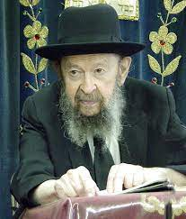

We said at a previous lecture that a man should pray for health even when he has it; he should ask Hashem that he shouldn’t get sick. But doesn’t that contradict the idea of אל יפתח אדם פיו לשטן – not to open your mouth to the satan by speaking of misfortunes that could occur (Brachos 19a)?

**ANSWER:** There’s a Jewish principle, not to speak about unfortunate possibilities. For example, a man shouldn’t say to his wife, “If one of us dies, then I’m going to Eretz Yisroel to settle.”

It’s a Jewish principle in how we speak.

It’s goyish to say like a boy said to his rebbe; he said, “Rebbe, if an ox would gore you and kill you, does he have to pay koifer?”  You don’t talk that way.  Jews don’t talk that way.

However, when it comes to tefillah, tefillah is just the opposite. You’re praying to Hakodosh Boruch Hu and that’s not פותח פה לשטן.  And we find everywhere that this kind of tefillah is employed. So you have a right to ask Hakodosh Boruch Hu to protect you, מדבר וחרב ורעב ויגון, a whole list of misfortunes, because when you’re praying to Hakodosh Boruch Hu, that’s the One to whom you can unburden yourself and you don’t have to worry.

But otherwise, in idle conversation, we don’t want to say anything that’s not happy.  Even to make yourself unhappy is not virtuous.  We always look at the sunny side of life and never mention misfortunes.

There are some people who are crabby and are always thinking about what might happen and Hakodosh Boruch Hu says, “If you’re misusing the opportunity I gave you to be happy, then I’m going to make you unhappy; I’ll bring misfortune on you and now you’ll look back and regret the good old days when things were going well.”

So don’t talk about misfortunes and not happy things.  But when it comes to prayer, then you can pray to Hakodosh Boruch Hu for all good things including that He should save you from all misfortunes.

TAPE # 77 (July 1975)

*Reprinted from the Parshas Korach 5783 email of Toras Avigdor based on Rabbi Avigdor Miller’s Tape #364 (June 1981) from his classic Thursday night lectures.*

**Rabbi Berel Wein on**

**Parshat Vaetchanan 5783**

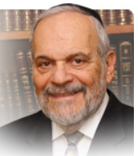

The Torah as we all well know is multilayered. The rabbis have taught us that there are seventy facets to every piece of the written Torah. We are also aware that no written word can adequately convey to us all of the nuances and possible meanings that lie embedded in the written word. The Torah requires elucidation, commentary and explanation in order for any proper understanding of its message to be gained.

The entire book of Dvarim is an elucidation and explanation of the first four books of Moshe. As such, by the inherent nature of explanation and commentary, different words and phrases will be employed to describe events and commandments that were previously mentioned in the Torah.

**The Two Words Stated by G-d Simultaneously**

A prime example of this appears in this week’s parsha where the Torah repeats for us the Ten Commandments revealed to Israel at Sinai. The wording here in Dvarim differs slightly from the wording recorded for us in Shemot. The Talmud in its rendition of the Oral Law states that these discrepancies – such as the use of the word shamor instead of the original zachor regarding the observance of the Shabat – indicate that these words were stated simultaneously by G-d, so to speak, a feat that is beyond human comprehension and ability.

The Talmud means to indicate to us with this statement that all of the possible interpretations and layers of meaning in the Torah were given to us simultaneously and at once at Sinai. Only the Oral Law and the work of the commentators to the Torah over all of the ages has revealed to us these original layers of meaning and interpretation for our study and practice. By using different words to explain what was already written, the Torah guides our understanding of the Torah only by way of the Oral Law and the great commentators of Israel over the ages.

In the final commandment of the Ten Commandments, the Torah here in Dvarim uses the word titaveh whereas in Shemot it used the word tachmode. The Torah points out to us that there are different forms of desire and wanting something. One is an impulsive, spur of the moment desire that arises out of seemingly chance circumstance – an advertisement in the media or a chance meeting or sighting. Such a desire is not planned and stems from the inherent human weakness within all of us to want to possess what we do not yet have. But there is another type of desire. It is long planned and had been part of our lives for years and decades. It borders on being an obsession or an addiction within our makeup.

**The Importance of Guarding One’s Eyes**

Both of these types of desire can destroy a person. The Torah cautions us against these symptoms of self-destructive behavior. And by the use of these different Hebrew verbs, the Torah indicates to us that there are different types of desires and that one must be defensive against all of them. The Talmud tells us that the eyes see and the heart thereupon desires. Guarding one’s eyes guards one’s heart as well. This example of the Torah’s self-elucidation of the matter makes the lesson clear to all and challenges us to apply it wisely in one’s own life.

*Reprinted from the current website of rabbiwein.com*

**The Quad Squad:**

***The Powerhouse Couple is Pushing Through with Total Faith***

**By Sarah Pachter**

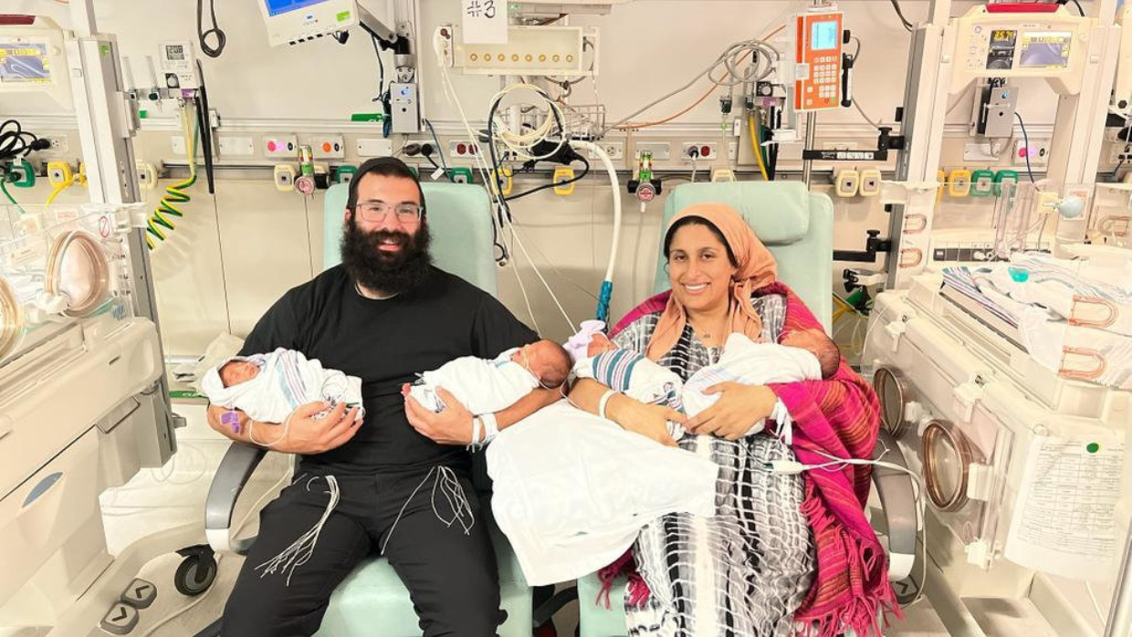

Rabbi Yisroel and Sara Gutovitch, a Los Angeles-based couple, gave birth to quadruplets on July 4th. They missed the traditional fireworks display but had their own celebration at Cedars-Sinai Medical Center instead. The babies, or the “quad squad” as their parents call them, are doing well. One is now home, and three of them are currently in the NICU. Their older brother, Chezzy, only three, is anxiously waiting to meet his other siblings.

After three years of infertility, this pregnancy—shockingly—came naturally. Sara Kahen Gutovitch’s first son came easily. She was pregnant soon after the wedding, had an uneventful pregnancy and easy birth. When it was not happening right away the second time around, the insensitive comments began. Acquaintances would ask, “*Nu*, when is the next one coming?”

“Our oldest was three, and I would see other couples who had been married much shorter than we were with more children and couldn’t help but feel I was falling into the baby Olympics trap. But I quickly realized these thoughts were not helpful. I decided to change my approach and outlook.”

**Responding with Vulnerability**

In the face of the hurtful comments, she decided to start responding with vulnerability, instead of embarrassment.

She’d say, “Actually, I would love nothing more than if you would pray for me.”

People usually froze when she answered this way, but sometimes they would respond, “Oh, I also had a miscarriage—did you try checking….” or “Try this thing I did, it worked…”

When Sara started sharing her vulnerability, she began feeling less alone and slowly but surely a community started to form.

After her miscarriage they tried IVF, which was not successful. She was devastated and took a pause in her efforts to have another child. Trying again right away felt too intense on her body and her emotions.

During this break, she started developing a healthier diet. Once she felt her body was in a better place, she worked on her spirituality. She had felt a spiritual void. She was praying but with hardly any emotion. She was saying the words, feeling empty inside. She also started reviewing [the laws of family purity](https://aish.com/how-judaisms-family-purity-laws-deepen-intimacy-and-connection/). This holistic approach empowered her body, soul, and mind to recover.

“We implanted the embryo [which was a girl], a few days after going to the mikveh (which ends the period of separation between husband and wife during menstruation and allows the couple to be intimate with each other). We had asked the doctors what to do and they said if anything, we might have twins.”

When they went to the doctor to see the first ultrasound, there was a pause. “What’s going on?” Sara and Yisroel asked, growing concerned.

**The Doctors Were Counting**

“We are counting,” the doctors replied.

“*Counting* *what*?” Sara thought.

The doctors informed them that there were four embryos and Sara and her husband started to laugh. “I’m not one to laugh nervously, but I couldn’t help it. My husband was standing against the wall and I watched him slowly sink to the floor.”

The doctors said, “Stop laughing, this is serious. You need to see a specialist immediately... today.”

Sara explained, “Unbeknownst to us, when we went in to do one egg transplant, we were already pregnant with triplets, and possibly quadruplets. We do not even know if that one implant worked. IVF is always saying it’s a 50-50 chance. They tell you for every two embryos, you hope to get one live birth. We put one in and walked away with four. None are identical. Totally fraternal.

“The pregnancy was a roller coaster. I think for the first ten weeks or so after we found out [15 weeks in] it was really walking on eggshells.”

Doctors were telling her to reduce the number of embryos. Everyone around her was scaring her with lines like: “You could lose your uterus. Are you sure you want to do this?” Medically, everyone was sharing the worst statistics with her.

“My doctor was not really giving his input, but everyone else was.”

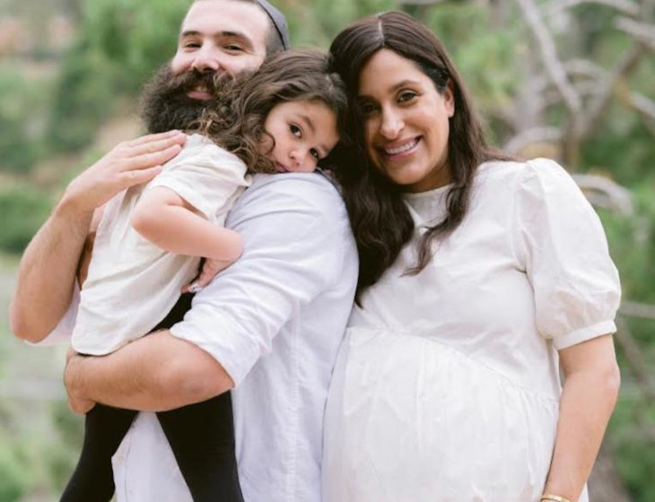

**Sara developed PCOS (Polycystic Ovary Syndrome), and after her first miscarriage, she began feeling isolated and alone in the process.**

Sara didn’t know what to do, and did not feel strong enough to make such a heavy decision.

She prayed, “G-d, I am not strong enough. I need You to take care of it. I am not sure who You think I am that You are assigning this to me. I do not want to be the one to make the decision to reduce. If You want to reduce, You take care of it.”

Medical appointments were fraught with fear and happiness. She’d wonder, *What if today is the day I do not hear a heartbeat?* Part of her knew she would be devastated and another part of her knew she’d be relieved. “My prayer was, ‘G-d, You figure this out.’

“Every time that I went in I saw that they were growing, there were heartbeats, and I saw ten fingers and ten toes. When I got word back from the amnio that everything was great, it reaffirmed the miracle and made me feel more confident that we are going to go all the way.”

**Fortunately, No Gestational Diabetes,**

**Hypertension or High Blood Pressure**

Fortunately, there were no major difficulties with Sarah’s pregnancy. No gestational diabetes, hypertension, or high blood pressure.

“The most transformative thing was seeing the doctors and nurses who were at first very hesitant jump on board with us. Initially, we said to them, ‘positive vibes only.’ Then towards the end of it when I got nervous, they would remind us, ‘positive vibes only.’

“I was determined to make it to my son’s birthday party. I was pretty stubborn, and said, ‘I can guarantee you these babies are staying inside me because I am not missing my son’s *upsherin* [third birthday party]. We are all in this together.”

Sara did make it to the birthday party but it was not easy to get to the end of the pregnancy. “I had to learn to trust my body and let it take the lead. I was on limited mobility, but did not let it stop anything. We went to Disneyland for Father’s Day. We went to the museum. I had to use a wheelchair, but I was kind to myself about that.”

Finally, the babies were ready to arrive and led by her High-Risk OB, Dr. Steven Rad, the staff at Cedars-Sinai Medical Center stepped up to the challenge.

**Exceptional Dedication by the Hospital Staff**

“Everyone at Cedars-Sinai was completely dedicated. It is really sweet to see people coming together for something good. They are all blown away by this miracle.”

Meredith Bevin, Registered Nurse, claims that this is the first set of quadruplets she has seen in 25 years in the NICU of Cedars-Sinai.

Quadruplets are extremely rare, and occur in only one out of every 700,000 pregnancies. Of the 3.6 million babies born in the U.S. in 2021, only 133 births involved quadruplets or higher multiples. 90% of all quadruplets are conceived through IVF. The doctors are not exactly sure as to what happened in Sarah’s case, but they know that at least three of the babies were natural, and possibly all four. These babies are pure miracles.

Sara agrees. “What happened is miraculous and not within the realm of nature. This does not happen otherwise.”

Her husband, Yisroel, added, “None of this is normal.”

**A Run of the Number “4”**

The four babies were born on the fourth of July, on the fourth floor, and each weighed just over four pounds. Sara’s sister, Sasha, ran to the grocery store to grab a few items—and the total was $44.44.

Sara felt like the numerous fours that kept appearing indicated that she was exactly where she was supposed to be, and that all of this was meant to be.

The new mother of the quads also has two MBA degrees and a thriving career working in business and strategy. She has now been thrust into this new role she does not fully feel prepared for, despite being a very accomplished woman.

As for the babies, Chaya is home, and Sarah is managing her time between her and the other three in the NICU.

Sara added, “I don’t know how it’s going to look when all of the kids come home, but I know G-d will help me. Nothing is too big for G-d, and now I approach things differently.

**Recognizing that G-d is Infinite and All-Powerful**

“Sometimes our own prayers can be limiting. I found myself praying that the babies would stay in the NICU longer because I did not have the car seats, I did not have the diapers, I did not really have anything. I realized I was praying from a fear-based approach not a love-based approach. G-d is infinite and all-powerful, and rather than praying from a place of scarcity, I realized I have to pray from a place of knowing G-d’s abundance and love. I thought, *What am I doing? I want the babies to come home! How we get the car seats and the diapers—G-d will help.*

“Suddenly, my uncle called. There was a store closing down, and he found car seats for 50% off and then discounted another 20%. He asked, ‘Do you want me to get four?’”

In addition to Chaya, whose name means “life” in Hebrew, the other baby girl has been named Shira, song, because she came out “singing” all night in the NICU. The two boys will be named once a bris is permissible for them.

She wants to encourage people to be intentionally sensitive to others. “You never know what issues people are dealing with, and thoughtless comments can be so painful.” Women experiencing infertility do not have to suffer in silence. “It’s important to open yourself up and share your struggles with others. Good vibes. Think good and it will be good.“

Sara also wants to inspire others to really see the miracles around them. “Even taking a deep breath and all that goes into it is miraculous.”

*Reprinted from the July 20, 2023 website of aish.com*